Python

1. What is the output of the following code?
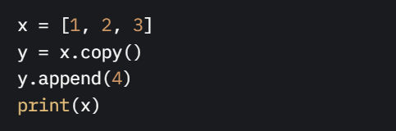
a) [1, 2, 3, 4]
b) [1, 2, 3]
c) [4]
d) Error

2. Which of the following creates a set comprehension for odd numbers from 1 to 10?
a) {x for x in range(1, 11) if x % 2 == 0}
b) {x for x in range(1, 11) if x % 2 != 0}
c) {x for x in range(1, 10) if x % 2 == 1}
d) {x for x in range(0, 10) if x % 2 != 0}

3. What does the following code return?
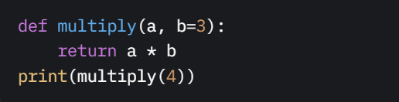
a) 12
b) 4
c) Error
d) None

4. Which of the following correctly checks if an element exists in a set?
a) `if element in set.keys()`
b) `if element in set`
c) `if set[element] is not None`
d) `if element.exists(set)`

5. What is the output of the following code?
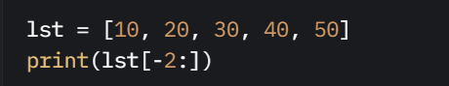
a) [30, 40]
b) [40, 50]
c) [50, 40]
d) [20, 30]

6. What happens when you run this code?
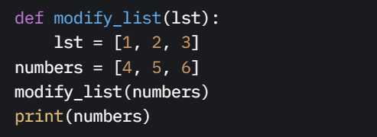
a) [1, 2, 3]
b) [4, 5, 6]
c) Error
d) None

7. What will the following code print?
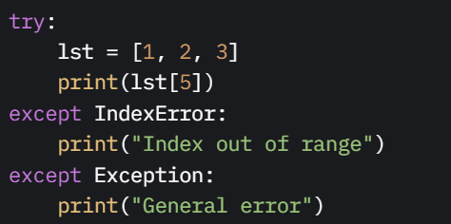
a) General error
b) Index out of range
c) Both messages
d) Error

8. What is the result of the following dictionary comprehension?
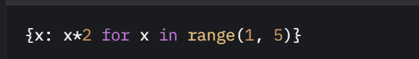
a) {1: 2, 2: 4, 3: 6, 4: 8}
b) {1: 1, 2: 2, 3: 3, 4: 4}
c) {2: 2, 4: 4, 6: 6, 8: 8}
d) {1: 2, 2: 4, 3: 6, 4: 8, 5: 10}

9. Which of the following lambda functions correctly returns the sum of two numbers?
a) `lambda x, y: x + y`
b) `lambda x, y: x * y`
c) `lambda x, y: x - y`
d) `lambda: x + y`

10. What is the output of the following code?
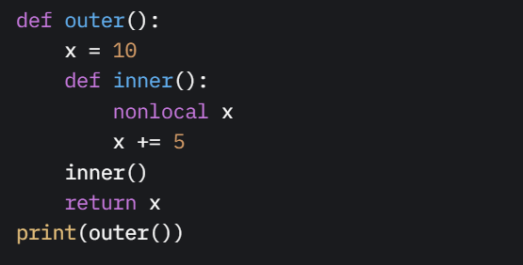
a) 10
b) 15
c) Error
d) 5

Statistics
- What is the mean of the dataset [2, 4, 6, 8, 10]?
  - A) 5
  - B) 6
  - C) 7
  - D) 8
- What does the standard deviation measure in a dataset?
  - A) Central tendency
  - B) Spread of data
  - C) Frequency of values
  - D) Correlation between variables
- What is the median of the dataset [1, 3, 5, 7, 9]?
  - A) 3
  - B) 5
  - C) 7
  - D) 9
- What is a p-value in hypothesis testing?
  - A) Probability of rejecting the null hypothesis
  - B) Probability of the null hypothesis being true
  - C) Probability of observing the data given the null hypothesis
  - D) Probability of accepting the alternative hypothesis
- Which measure is affected most by extreme values in a dataset?
  - A) Median
  - B) Mode
  - C) Mean
  - D) Midrange

Machine Learning
- What is the purpose of a training set in machine learning?
  - A) To evaluate the model’s performance
  - B) To tune hyperparameters
  - C) To fit the model
  - D) To test the model
- Which algorithm is commonly used for classification tasks?
  - A) Linear Regression
  - B) K-Means Clustering
  - C) Logistic Regression
  - D) Principal Component Analysis
- What is overfitting in machine learning?
  - A) Model performs well on training data but poorly on test data
  - B) Model performs poorly on both training and test data
  - C) Model is too simple to capture patterns
  - D) Model cannot be trained
- What does the following Scikit-learn code do? 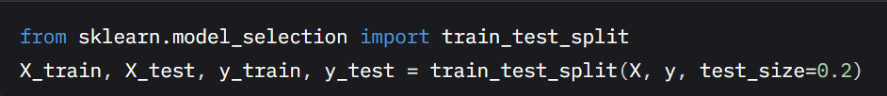
  - A) Scales the features
  - B) Splits data into training and test sets
  - C) Fits a model
  - D) Evaluates model performance
- Which metric is used to evaluate a classification model’s performance?
  - A) Mean Squared Error
  - B) R-squared
  - C) Accuracy
  - D) Root Mean Squared Error
- What is the purpose of cross-validation in machine learning?
  - A) To preprocess data
  - B) To reduce model complexity
  - C) To assess model performance robustly
  - D) To select features
- What is the output of the following code?
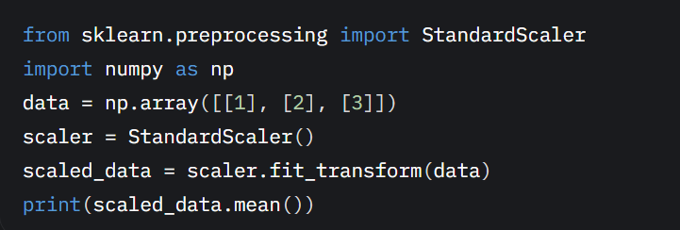
  - A) 0
  - B) 1
  - C) 2
  - D) Error
- Which algorithm is an example of unsupervised learning?
  - A) Decision Tree
  - B) K-Means Clustering
  - C) Support Vector Machine
  - D) Linear Regression
- What is the role of a loss function in machine learning?
  - A) To split the dataset
  - B) To measure model error
  - C) To select features
  - D) To visualize data
- What does the fit() method do in Scikit-learn?
  - A) Evaluates the model
  - B) Trains the model
  - C) Predicts new data
  - D) Scales the data
- What is the purpose of regularization in machine learning?
  - A) To increase model complexity
  - B) To prevent overfitting
  - C) To speed up training
  - D) To reduce dataset size
- Which of the following is a hyperparameter in a Random Forest model?
  - A) Number of trees
  - B) Predicted labels
  - C) Feature weights
  - D) Training data
- What does the following code do?
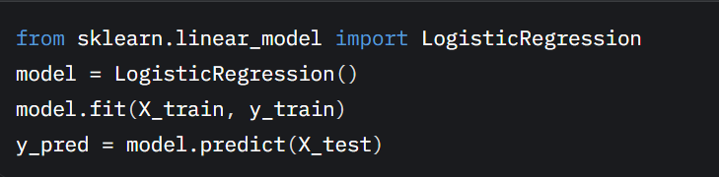
  - A) Scales the test data
  - B) Trains and predicts using a logistic regression model
  - C) Performs cross-validation
  - D) Clusters the data
- What is the purpose of a confusion matrix?
  - A) To visualize feature importance
  - B) To evaluate classification model performance
  - C) To scale features
  - D) To reduce dimensionality
- What is the main advantage of using a decision tree?
  - A) Handles non-linear relationships
  - B) Requires no preprocessing
  - C) Always provides the best accuracy
  - D) Reduces dataset size

